- What is Lamplight?
Lamplight is a cloud-based software package to manage VA’s Befriending Services. This means you can log on anywhere via a computer or phone or tablet and report your calls and visits, as and when you make them.
Lamplight is a comprehensive software package, which can collect and report information in many ways. This guide tells you about the elements of the system which are essential to you as a volunteer and ignores everything else!

- Accessing Lamplight
VA will register you on the system. An automated email address will be sent to you when this is done. The email will be sent from noreply@lamplight.online Please, check your junk box, if you can’t find it.
The text on the email will tell you that your password has been changed. Please click on the link and use this ‘new’ password and your email address to access the system. You will be invited to reset your password. The password must be at least 10 characters long.
DO NOT ALLOW YOUR INTERNET BROWSER TO AUTOMATICALLY SAVE THE PASSWORD. WE HAVE BEEN WARNED THAT THIS CAN CAUSE PROBLEMS WITH THE SYSTEM.
Lamplight recommend that you use Mozilla Firefox, Google Chrome or Edge browsers. If you are using Microsoft Internet Explorer, they suggest you use the most up-to-date version.
The system should be available on all types of devices. If using Apple equipment (iPads and iPhones) please make sure your version of Safari is up to date. We have tested the system on as many devices as possible, but have not been able to test all types of Android devices. Please contact us, if you experience a problem.
The Lamplight system is routinely accessed at https://lamplight.online/ using your email address and the password you have created. Please remember to use the Logout button (top right) when you finish a session.

- What you should see when you log in (the Home Page)
Your Home Page should look similar to the screen shot below.
- Your name will appear with the description STAFF following it (see the red circle below). You are not a member of staff (obviously), but that’s how the system defines you.
- There is a Search box and a logout button in the top right hand corner of the home screen.
- The menu above the blue ribbon is always visible. If you get stuck at all or make a mistake, select the home button (without saving) and you can start again). You shouldn’t really need to use any of the other options in these tabs, but there are a Help button and a help tab, if you are interested in this sort of thing.
- The tabs below ‘Welcome to Lamplight’ (highlighted in green) allow you to input the information we need. See the instructions below.
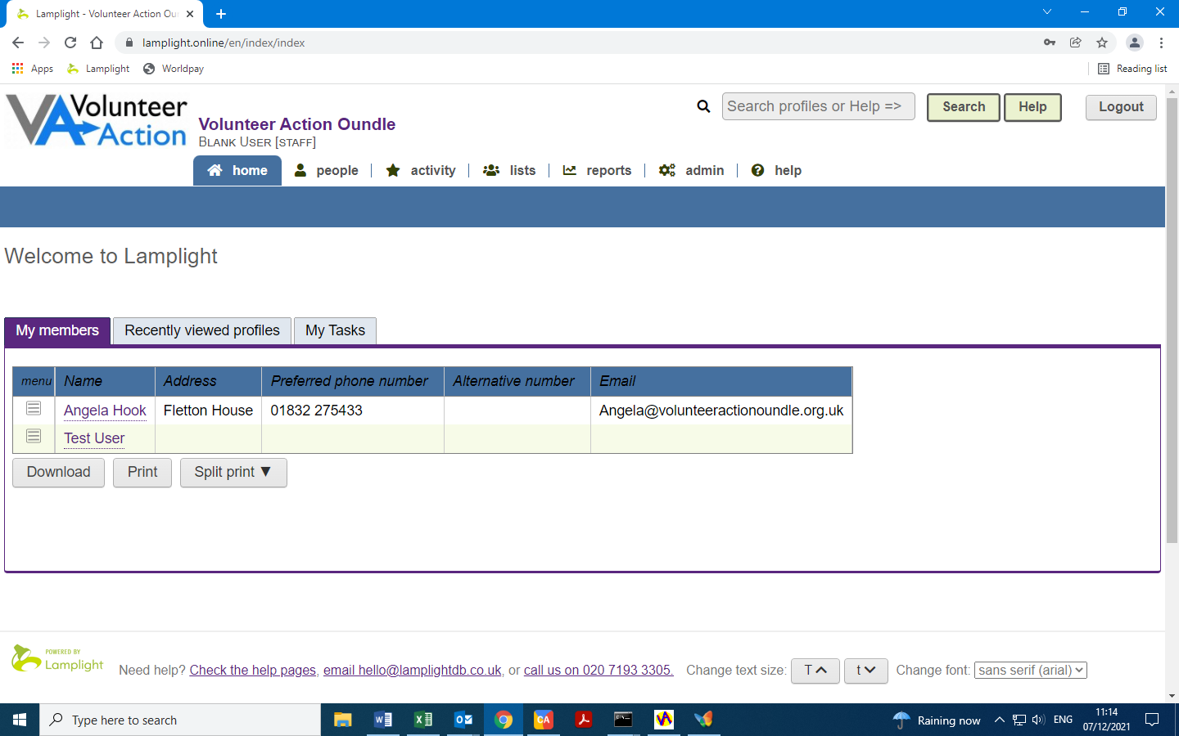
- Information about your Befriendees
Once you have logged in, use your “My Members” tab to see a list of your Befriendees. This may just be one person, or a list of multiple Befriendees.
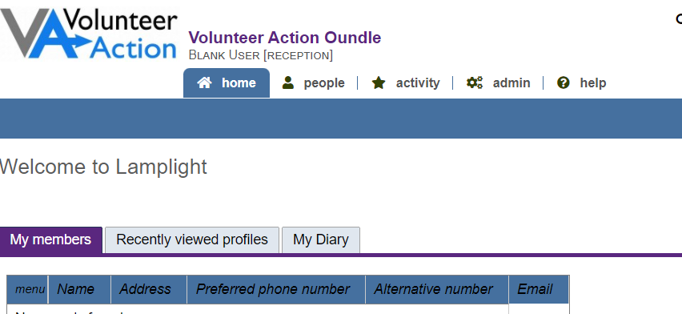
Click on an individual’s name to access their profile. You will see three tabs: Contact details, Work Records and Risk Assessment. It is possible for you to edit the Contact Tab and the Risk Assessment tabs. Please don’t do it! Also please note that the ‘Call’ button next to the member’s phone number will not work. The risk assessment tab will eventually hold information useful for Face to Face Befrienders (the data needs to be transferred from our paper files) but will be blank for Telephone Befriendees.
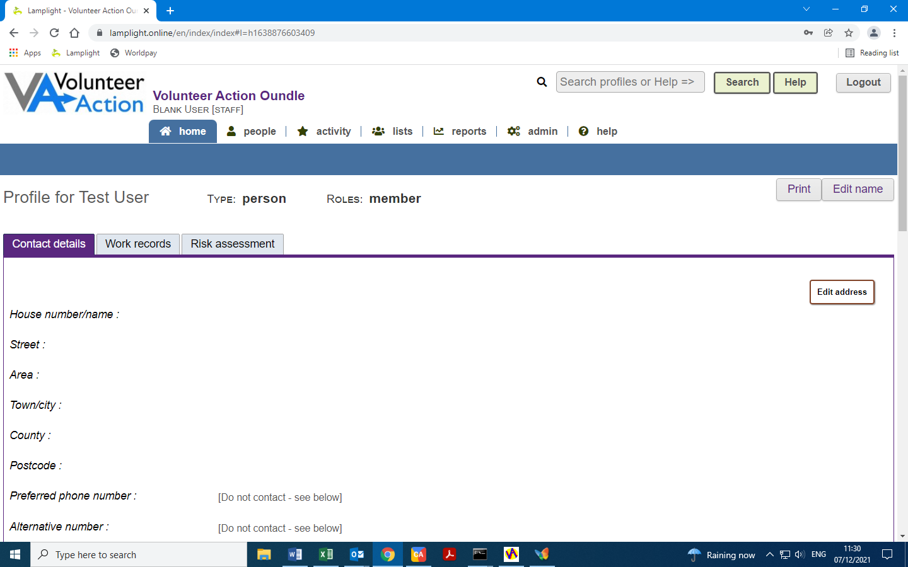

- Recording your visits and calls on Lamplight
“Work records” are the way to record the calls and visits you make.
Select the tab “My Members”, as above, and choose the person you have visited/called. You will then be looking at your Befriendee’s profile.
Select the ‘Work Records’ tab on their profile, and then click the ‘Add’ button to the right. The resulting pop-up window is where you will enter the details of the visit/call. We have tried to keep this as simple as possible, but there are some choices to make.
See screenshot on the next page
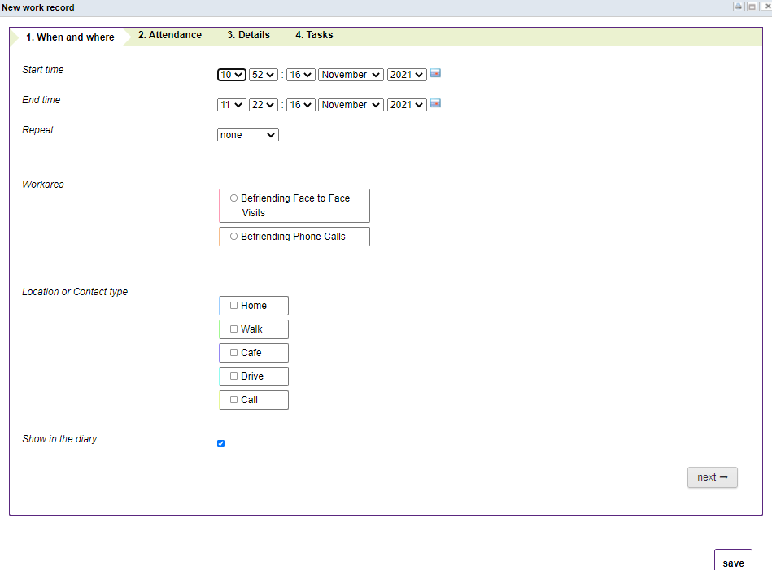
There are four tabs. You will need to populate the first 3 every time. They are:
- When and where
- Attendance
- Details
You can move between tabs by using the tab headings or you can use the next -> button (bottom right). Save when you have completed all tabs.

4.1 When and Where
- Date and time
Select your start time, and the end time will automatically change. In each field, click on the little arrow to the right of the field and select from the drop-down list that appears. The default length of work records has been set to 60 minutes, but you can change the end time manually, as appropriate.

If you have called and were unable to get through, please record this too, as a 1 or 2-minute call. A record of all your attempted contacts is valuable.

Next, set the date. The ‘start and ‘end’ dates will usually be the same. You can use either the drop down menus or the calendar icon to select the correct date.
- Work areas
When you create a work record, you must select one work area, and you might choose one or more sub-work areas too. These are essential as they categorise everyone’s records so that you and VA can easily sort through and report on them. For the work area you can select a Befriending Face to Face visit or Befriending Phone call. If you select Face to Face a second pop-up will appear. Please select “Regular visit” for this (staff in the office use the other options).
- Location or Contact type
As well as a work area, you may select a Location. If you are reporting a phone call, just ignore the Location fields. If you have made a face-to-face visit, you will probably select the ‘Home’ option, but if you met your befriendee for a walk or at a café, for example, this may be different. Please select the correct option.

4.2 Attendance Tab
Next is the attendance tab in which we record the individuals involved. Either select the Attendance tab at the top of the window or choose the next button (bottom right). In most cases the attendees will be just you and your Befriendee and the table should be automatically populated. If you need to add anyone else (e.g. a member of VA staff), use the Find Profiles box at the top of this window. Start typing a name and select the name when it appears on the drop down list.

4.3 Details
Next is the ‘Details’ tab. Here you tell us about your visit or call.
- Summary
The text you enter in the ‘Summary’ field is almost like a title, so make it succinct. Think of it as the subject line in an email, for example, “Phone call with John”, “Visit to Sue” “Unsuccessful call to Fred”. Placing the cursor in the field will usually reveal rich-text editing tools, which provide formatting options. However, we are not expecting you to do any formatting.
- Description
The ‘Description’ field is for notes from the session. Let us know how things went, how your Befriendee seemed, any interesting information you’ve discovered such as hobbies or interests etc. This does not have to be long (e.g. “Everything seems fine”), but is helpful as a record.

4.4 Saving
At this point, you can save your work record by clicking the ‘Save’ button in the bottom right-hand corner. Note that the system DOES NOT automatically save entries. You must actively select the Save button or your entries will be lost.
You will now be presented with a display of the information you have entered. Please check it. Any errors can be corrected by using the Edit button on the right hand side of this screen. Save again.

5 Concerns about your Befriendee
However, you may have some concerns about your Befriendee. If this is the case, you have three options:
- You can go down the ‘old-fashioned’ route and just call the office to talk to someone. Please do this if it is urgent (e.g. a safeguarding issue).
- You could send an email to befriending@volunteeractionoundle.org.uk
- You can raise a Task on the Lamplight system. To do this …
5.1 Raise a Task
To do this use the 4th tab on the current or an existing Work Record, labelled Tasks.
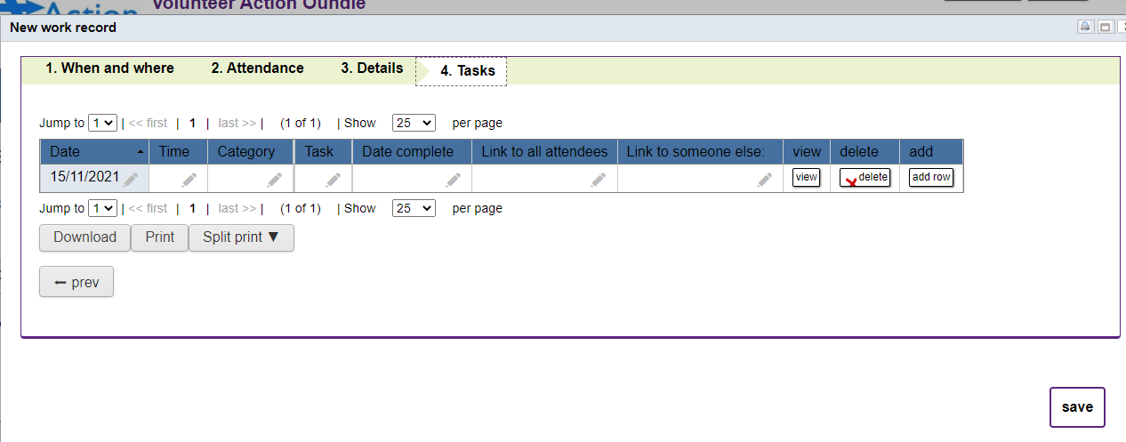
Click on the pencil to edit each field in the table row.
- The date will be set to the current day.
- Set the Time field to the time of reporting.
- Category is a drop down list – choose Alert/Concern
- Task field – please enter a short description, e.g. “Please phone me”, “Please phone John B”, “See visit notes for 14 October”
- Leave ‘Date completed’ blank, please. This is for Office use.
- Link to all attendees. To do this, click on the pencil, select the ‘attendees’ tick box and Save (Green button)
- Link to someone else – start typing and select Angela Hook
- SAVE!! Use the button at the bottom RHS of this screen
We will get back to you as soon as we can. Remember that all staff at VA work part-time hours, so may not pick up a system message immediately

6. Editing Existing Work Records
If you need to change work records that have already been saved to the system you can do so. You may have realised you entered the wrong date, for example.
- From the home screen chose activity, work, all.
- A table of all your work records for the last 12 months will be displayed
- Click on the icon in the first column of the table (the menu column) for the relevant entry. The icon looks like a picture of a list.
- You have the option to view or edit the record. Use the instructions above to edit.
- You also have the ability to delete a record. You should not do this without consulting with the office.

7. Adding more work records
If you need to input more than one call/visit, the easiest ways to do this are:
- Either go back to your home page and click on your Befriendee’s name again
- Or start typing your Befriendee’s name in the search box and select their name from the drop down list.
Then, select their Work Record tab and repeat the instructions in section 4 above.

8. Logout
Logout (button top right of Home Screen) when you have finished your session. However, there is an automatic logout after 20 minutes of inactivity.

